Rechargeable Hair Clipper
Model No.: JH-826/JH-828
Instruction Manual
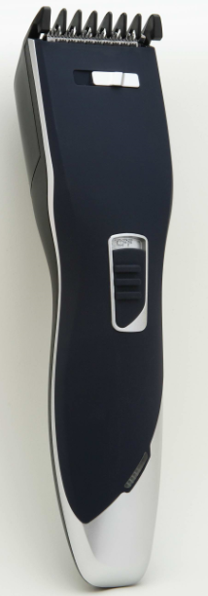

Dear Customers!
The hair clipper with two easy replaceable comb attachments provides possibility of obtaining different lengths of cutting and clipping hairline. Additionally, the feature of thinning is available.
Please read these instructions carefully. Pay your special attention to important safety instructions. Keep this “Instructions for use” for future reference.
Safety instructions and recommendations
Herewith information concerns your health and safety. It is obligatory to learn about all instructions for use and safety information before first usage of the clipper.
- The hair clipper is intended for domestic use. In case it is used for commercial use, the guarantee conditions change.
- Connect the power supply adaptor to AC mains supply 100-240 V.
- Disconnect the power supply adaptor from the mains supply outlet when not in use or before cleaning.
- Do not unplug pulling by the cord.
- The supplying cord should not hang over the edge of a table or desktop, nor touch hot surface.
- This device is intended for cutting natural hair, only. It is allowed to use it only for human hair; it can not be used for cutting artificial or animal hair. Using the product for other than intended purposes shall cause nullifying the guarantee.
- Do not touch the power supply adaptor with wet hands, especially when plugging or unplugging it from the mains supply outlet.
- For the operation with mains use only the adaptor supplied with the hair clipper.
- Connect only to easily accessible mains supply outlet.
- Do not cover the adaptor; it can lead to dangerous temperature increase.
- Do not use during bath.
- Never immerse the device and cord in water or other liquids.
- Do not place the hair clipper on wet surface or cloth during operation.
- Do not place or store the device in the area where it can fall into water.
- Do not use the device with damaged comb attachment. It can cause injuries hazard.
- Never try to remove the foreign bodies out of the clipper using sharp objects (i.e. comb).
- Always clean after using.
- This appliance can be used by children aged from 3 years under supervision and persons with reduced physical, sensory or mentalcapabilities or lack of experience and knowledge if they have been given supervision or instructionconcerning use of the appliance in a safe way and understand the hazards involved. Children shall notplay with the appliance. Cleaning and user maintenance shall not be made by children withoutsupervision.
- Do not apply not recommended attachments.
- The hair clipper can be used both as a mains and cordless device.
- The cut hair should be clean, dry and combed.
- Put the towel around the neck to avoid getting the cut hair under the collar.
- Use the hair clipper only as intended according to the herewith instructions.
- This appliance contains batteries that are non-replaceable.
- Use only with <RY025100EU> supply unit.

WARNING:For the purposes of recharging the battery, only use the detachable supply unit provided with this appliance

WARNING: Do not use the device near water, over the bath tube, pool or other water basin.
WARNING: Observe the above mentioned rules in order to avoid burning, electric shock or fire hazard.
Make sure you understood the instructions.

Description of the Parts
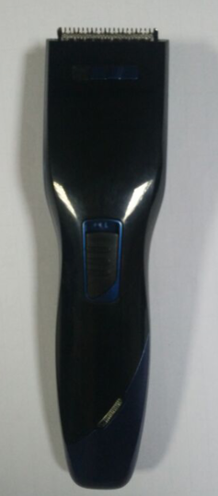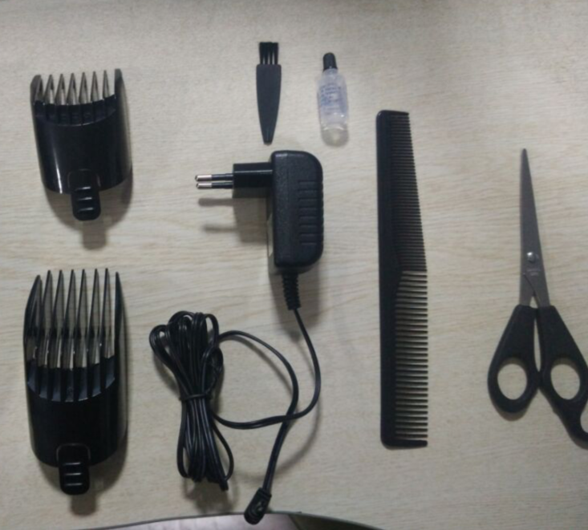
1
2
3
4
5
6
7
8
9
10

- Cutting head
- Thinning function knob
- On/off Switch
- Charging light
- Combs : 3/6/9/12/15mm & 18/21/24/27/30mm
- Power supply adapter
- Cleaning brush
- Blade oil
- Barber comb
- Scissors

Handling and operation of hair clipper
The hair clipper can be used both as a mains supplied or cordless device.
1. Operation with power supply adaptor
At first insert the adaptor plug into the device and then insert the adapter plug into the mains supply outlet (100-240 V). In mains supplied mode the device is ready for use.
2. Loading accumulators and cordless operation
TIP: Load the device minimum 12h before first usage and when 2–3 next loadings.
In order to load the device moving the ON/OFF switch to „OFF”position.
Insert the plug of the adapter into appropriate mains supply outlet (100-240 V). The loading process is indicated by red pilot light glowing. When fully loaded the hair clipper can operate approximately 40 minutes.
The hair clipper accumulator obtains optimum power after three cycles of loading and unloading. 8 hours is enough for next loading. In order to –– provide long life of accumulators, they should be completely unloaded before loading.
3. Using the clipper for hair cutting and thinning
TIP: Cut the hair for demanded length in stages, start form bigger length.
Insert appropriate comb attachment.
Set the desired length of hair/beard. The length of clipped hair is indicated (In millimeter) at the length indicator on the comb attachment.
Turn on the device on and Cut only small areas.
Move the clipper slowly along hair.
Hold the device so, that the comb attachment is laid flat.
Always start the cutting from the neck upwards or from the forehead and temples upwards to the top of head.
In order to thin the hair, turn the hair thinning knob to the left position; the thinning attachment integrated with cutting head shall be moved up from the housing.
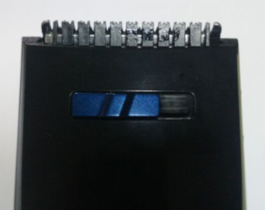
You can reduce the hair volume with this feature. It provides a modern, changed look without the change of hair length.
4. Cutting hair without attachment
WARNING: The cutting head (1) is very sharp. Injury hazard!
You can cut the hair in uniform length of 1–2 mm without comb attachment.
For clipping the hairline of bristle and whiskers, neck shaving:
Move the hair clipper slowly along hair.
Turn the device so, that the back part was directed upwards.
Place the edge of the cutting head without comb attachment on desired length of bristle hairline.
Move down the clipper in operation.
5. Comb attachments inserting/replacing
It is possible to select one of two comb attachments:
The small attachment can cut hair for the length of: 3 mm, 6 mm, 9 mm, 12 mm, and 15 mm.
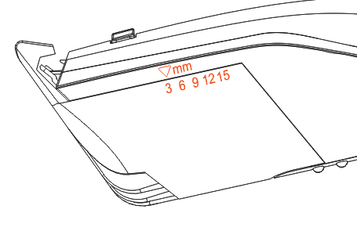
The big attachment can cut hair for the length of: 18 mm, 21 mm, 24 mm, 27 mm, and 30 mm.
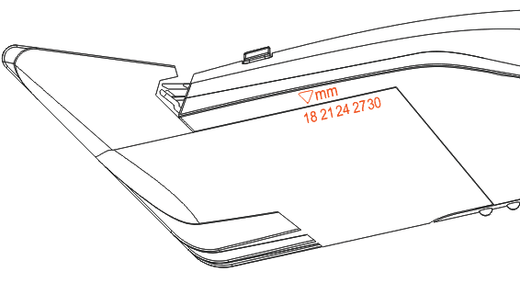
Select the attachment according to the length of cutting.
Insert it into the side guiding grooves of the clipper.
Replace one attachment removing it and inserting another as described above.
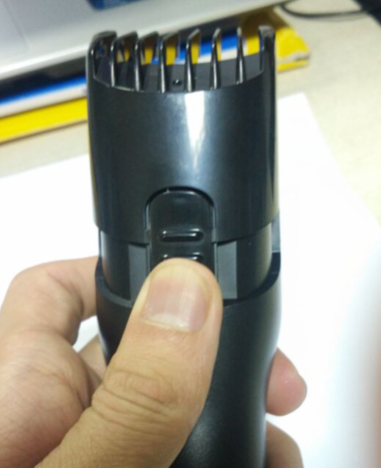
Cleaning and maintenance
Do not hold the adaptor with wet hands while plugging and unplugging form mains supply outlet.
The adaptor and supplying cord should be always dry.
It is forbidden to immerse the hair clipper in water or other liquids for cleaning, as the device is not waterproof. It can damage the live parts (accumulators).
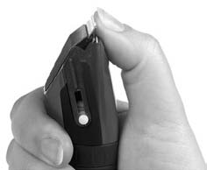
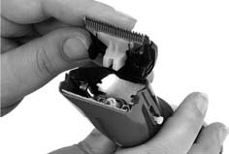
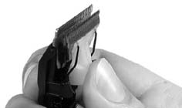
Always switch off the hair clipper and unplug the adaptor from the mains supply outlet before cleaning and ––maintenance.
Remove the comb attachment from the hair clipper.––
In order to remove the cutting head, press forward cutting head with your thumb, in order to release the cutting head from the frame.
If necessary, rinse the plastic comb attachments under running water, and then dry them thoroughly.
Remove the remains of hair from the cutting head with attached cleaning brush.
Insert the protrusion of cutting head back into the locking hole in the frame of cutting head.
Press gently the cutting head in, until you hear a clicking sound of locking.
TIP: In order to reduce friction, from time to time insert one or two drops of oil between the blades and distribute it evenly.
You can use any kind of acidless oil (such as oil for sewing machine). Remove the exceeding oil with cloth.
Specifications
The product technical parameters are included at the name plate.
The device is built in II class isolation, it does not require grounding.
This hair clipper meet the requirements of effective standards.
The device meets the requirements of the following directives:
Low Voltage Device (LVD) – 2006/95/EC.
Electro- Magnetic Compatibility (EMC) – 2004/108/EC.
The product is marked with CE symbol on the name plate.

Ecology – Environment protection
Each user can contribute to protect the environment. It is neither difficult nor expensive. In order to do so:
Return cardboard packages to recycling points.
Throw polyethylene (PE) bags into appropriate containers.
Batteries contain substances harmful to the natural environment. Do not throw them away with other household waste. Return used batteries to recycling points. Before disposing of or returning the appliance to a recycling point make sure to remove the batteries from the battery compartment.
Return a worn out appliance to an appropriate collecting point as the components of the appliance may pose a threat to the environment.
Do not dispose into the domestic waste disposal!
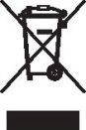
The manufacturer/importer does not accept any liability for any damages resulting from unintended use or improper handling.
The manufacturer/importer reserves his rights to modify the product any time in order to adjust it to law regulations, norms, directives, or due to construction, trade, aesthetic or other reasons, without notifying in advanc

